65.12.15a
Transfer of Title
archival location?, SA.

(C)
CERTIFICATE OF TITLE
Register Book
Vol. XXXIII Folio. 167

Ferdinand Jacob Heinrich Müller of Melbourne in the Province of Victoria Government Botanist is now seised of an estate in fee simple subject nevertheless to such encumbrances liens and interests as are notified by memorial underwritten or endorsed hereon in That piece of Land situated in The Hundred of Macclesfield County of Hindmarsh being part of the Section numbered 2852 containing nineteen acres three roods and two perches or thereabouts and bounded as appears in the plan drawn in the margin hereof and therein colored green Which said piece of Land measures on the Southerly side next a Government road measuring from the Government road intersecting the said Section nine chains and fifty three links or thereabouts the boundary line then turns northerly next other part of the said Section twenty one chains and twenty six links or thereabouts then easterly next part of Section 2831 four chains and fifty three links or thereabouts then southerly one chain or thereabouts then Easterly five chains or thereabouts to the aforesaid road intersecting the said Section 2852 and then southerly twenty chains and twenty six links to the point of Commencement Which said Section 2852 is delineated in the public map of the said Hundred deposited in the Office of the Surveyor General and was originally granted the twenty third day of April 1849 under the hand and seal of Sir Henry Edward Fox Young Lieutenant Governor of the said Province to Samuel Davenport

In witness whereof, I have hereunto signed my name and affixed my seal this twenty ninth day of September one thousand eight hundred and sixty two
R R Torrens
Registrar-General

Signed, the 29th day of Sept 1862 in presence of H P Denton

Transfer No. 12422 dated the 5 day Decr. 1865 produced the 15 day Dec. 1865 at Ten o'clock a.m. from the above named Ferdinand Jacob Heinrich Müller to James Harriss of Bugle Ranges Farmer of the above land Consideration money paid £85.
Entered the 15 day Dec 1865 at Ten o'clock a.m.
W Bacon Carter Dep. Registrar General
This Certificate of Title is cancelled and a new Certificate of Title is issued Vol. XXXVII Folio 86
W B T Andrews Registrar-General

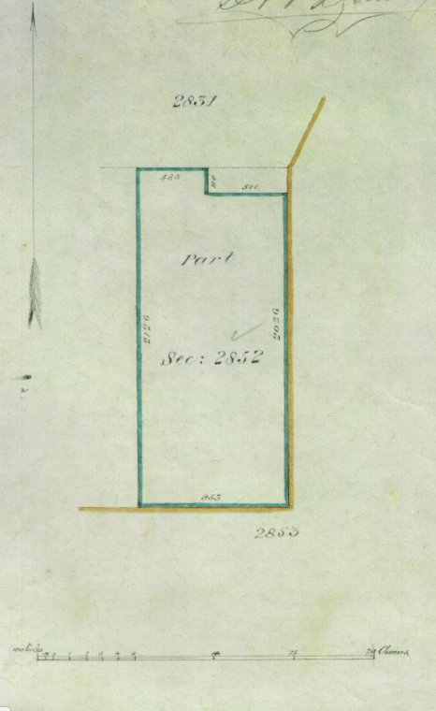

Document headed by coat of arms of SA. MS annotation: 'A. 3247'.
The seal of the 'Registrar General South Australia' is next to the signature.
The plan of the land described is below this signature: 65-12-15a_image01.jpg

